**SSRS IN SHAREPOINT MODE INSTALLATION GUIDE**

**Table of content**

A. Versions 2

B. Prerequisites 2

C. Installation 2

I. Step 1: Install Reporting Services Report Server in SharePoint mode 2

II. Step 2: Register and Start the Reporting Services SharePoint Service 6

III. Step 3: Create a Reporting Services Service Application 8

IV. Step 4: Activate Report Server Integration Feature 10

VI. Step 6: Deploy from SQL Server Data Tool 12

1. **Versions**

* SQL Server 2014 Enterprise per core.
* SharePoint 2013.

1. **Prerequisites**

* .Net Framework 3.5 (required by SQL Server 2014)
* Existing SharePoint farm (this document assumes that the SharePoint farm has been installed successfully before below steps are initiated. Please refer to another document for SharePoint installation if needed).

1. **Installation**

This guide line is just appropriate for the versions of software described in the Version part. The installation process listed out in this document could differ from other versions.

1. **Step 1: Install Reporting Services Report Server in SharePoint mode**

This step installs a Reporting Services report server in SharePoint mode and the Reporting Services add-in for SharePoint products. Depending on what is already installed on the computer, some of the installation pages described in the following steps may not be seen.

1. Run the SQL Server Installation Wizard (Setup.exe).
2. Click **Installation** in the left side of the wizard and then click **New SQL Server stand-alone installation or add features to an existing installation**.

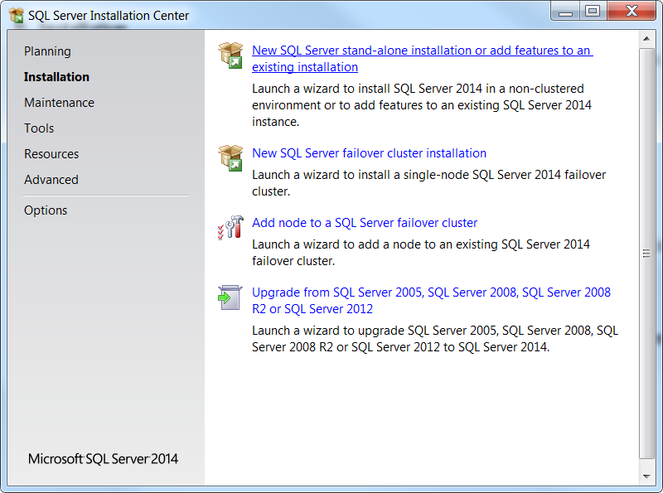

1. Skip the **Microsoft Update and Product Update** by clicking **Next** without checking any options.
2. Make sure all rules in the **Install Rules** step ***passes***, then click **Next**. If there is any rule in the other status rather than ***passes,*** click the link for more information.

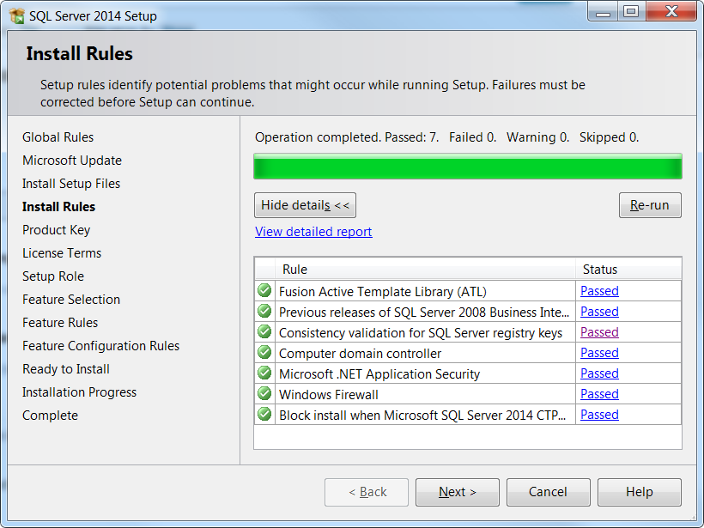

1. Enter product key, then click **Next.**
2. Check to accept the license terms, then click **Next.**
3. Choose **SQL Server Feature Installation** option from the **Setup Role** step, then click **Next.**
4. Select the following on the **Feature Selection** page:

* **Reporting services – SharePoint.**
* **Reporting Services add-in SharePoint Products.**
* If there is no existing instance of SQL Server Database Engine yet, select **Database Engine Services** and **Management Tools Complete** for a complete environment.

***Note:*** if .Net Framework 3.5 has not been setup, the installation will not be able to proceed further from this page.

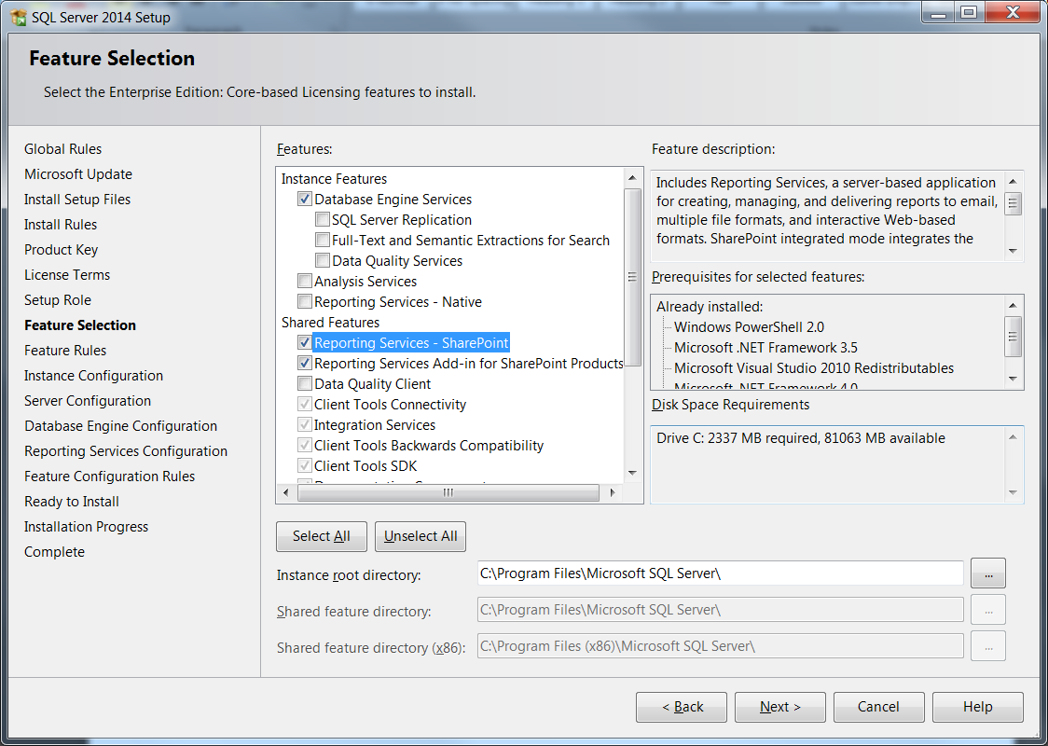

1. If the **Installation Rules** page shows up, review any warnings or blocking issues. Then click **Next.**
2. If the **Database Engine Services** was selected in the previous step, then accept the default instance of **MSSQLSERVER** on the **Instance Configuration** page and click **Next.**
3. Select appropriate credentials in **Server Configuration** page, click **Next.**
4. If the **Database Engine Services** was selected in the previous step, **Database Engine Configuration** page will be displayed, then add appropriate accounts to the list of SQL Administration and click **Next.**
5. On the **Reporting Services Configuration** page, there is only one option **Install only** is available to be selected, click **Next.**

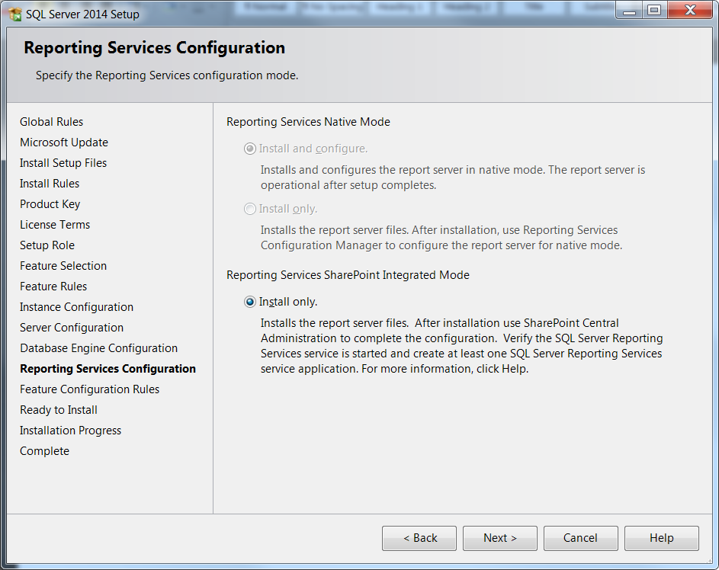

1. Review any warnings and then click **Next** on the **Installation Configuration Rules** page.
2. On the **Ready to Install** page, review the installation summary and then click **Next**. The summary will include a **Reporting Services SharePoint Mode** child node that will show a value of **SharePointFilesOnlyMode**. Click **Install**.
3. **Step 2: Register and Start the Reporting Services SharePoint Service**
4. In **SharePoint Central Administration**, click **Manage Services on Server** in the **System Settings**group.

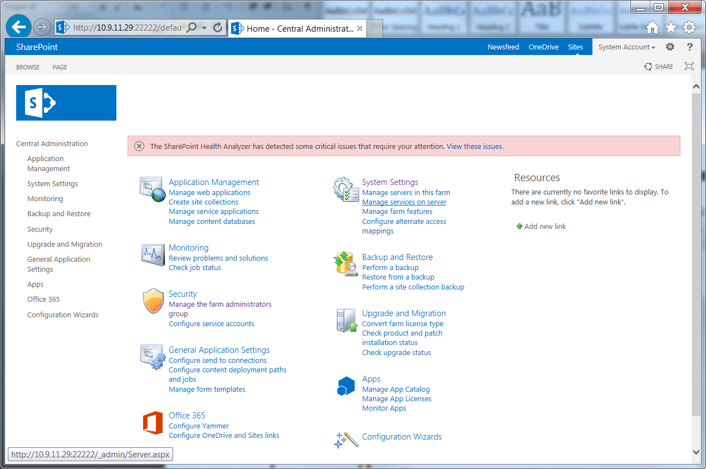

1. Find **SQL Server Reporting Services Service** and click Start in the Action column.
2. The status of the Reporting Services service will change from **Stopped** to **Started**.

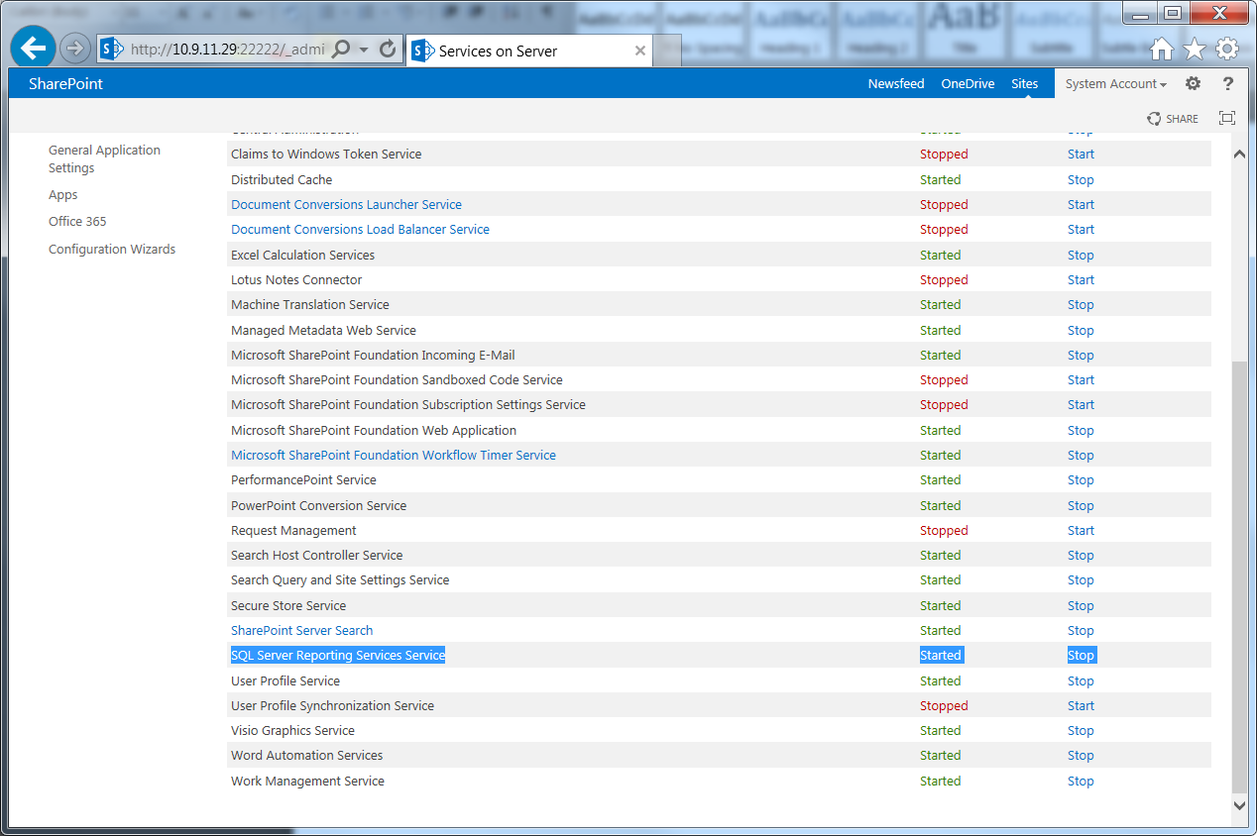

***Note:*** If the Reporting Services service is **not** in the list, perform the following steps to install the service.

1. Click the **Start** button
2. Click the **Microsoft SharePoint 2013 Products** group.
3. Right-click **SharePoint 2013 Management Shell,** click **Run as administrator**.
4. Run the following PowerShell command to install the SharePoint service. A successful completion of the command displays a new line in the management shell. **No message is returned** to the management shell when the command completes successfully.

* Install-SPRSService
* Install-SPRSServiceProxy
* get-spserviceinstance -all |where {$_.TypeName -like "SQL Server Reporting*"} | Start-SPServiceInstance

1. **Step 3: Create a Reporting Services Service Application**
2. In SharePoint Central Administration, in the **Application Management** group, click **Manage Service Applications.**

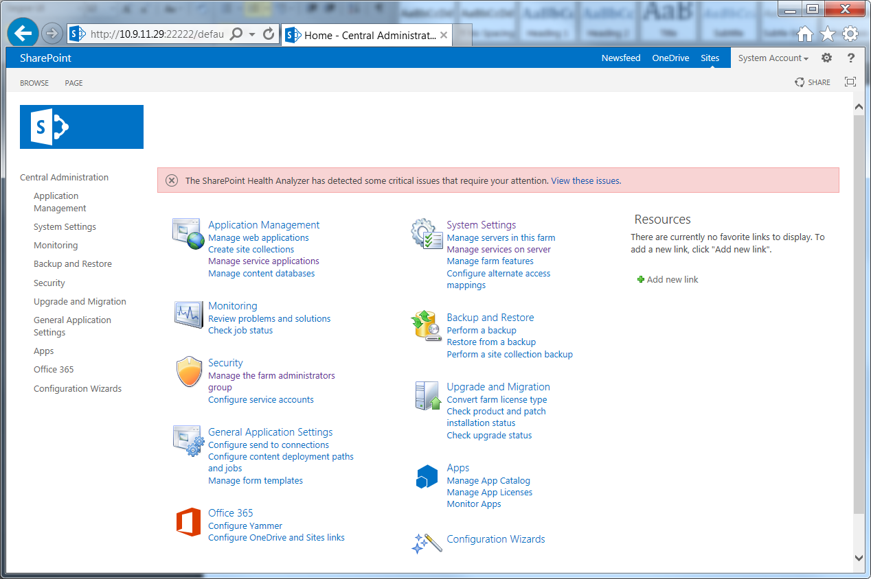

1. In the SharePoint ribbon, click the **New** button.
2. In the New menu, click **SQL Server Reporting Services Service Application.**

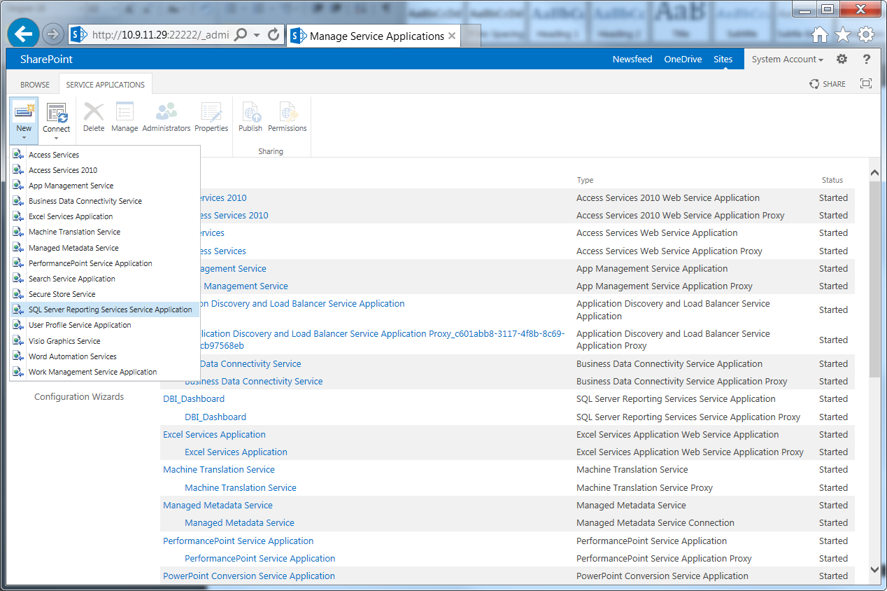

1. Type the name for the new application.
2. Create a new **Application Pool**, and specific a name for it.
3. Provide the **Security Account** for the application pool.

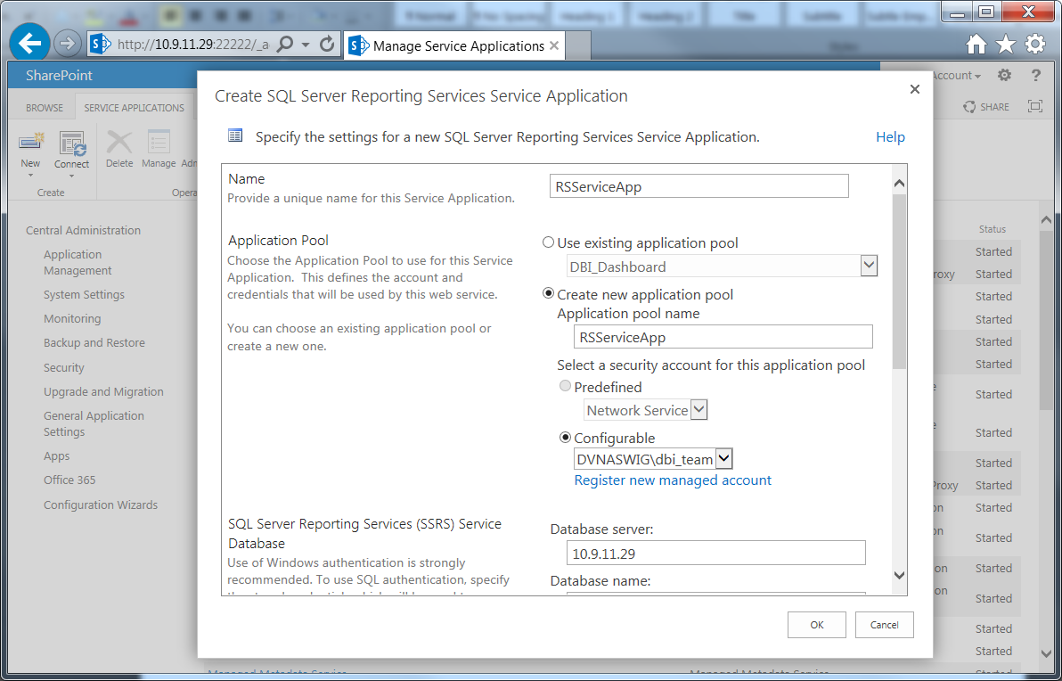

1. Provide **SQL Server Reporting Services Service Database** address, and credential to connect to that database.
2. And finally, select a **Web Application** that can be associated with the service application. Then click **OK**

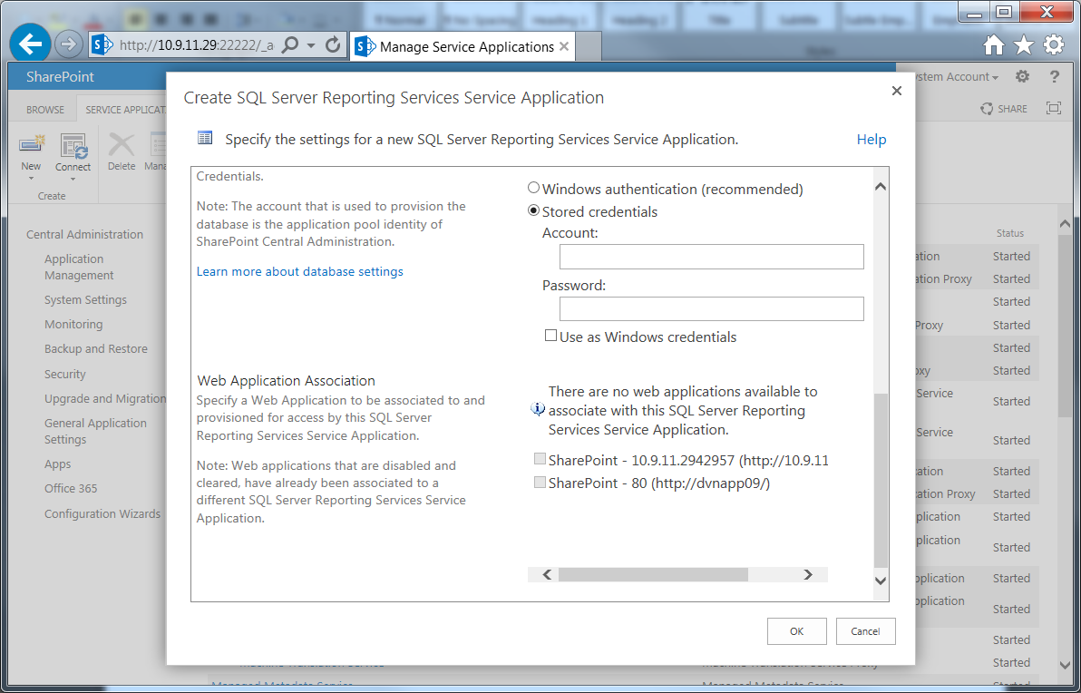

1. **Step 4: Activate Report Server Integration Feature**
2. Open **Site Setting**, under **Site Collection Administration**, click on **Site collection features.**

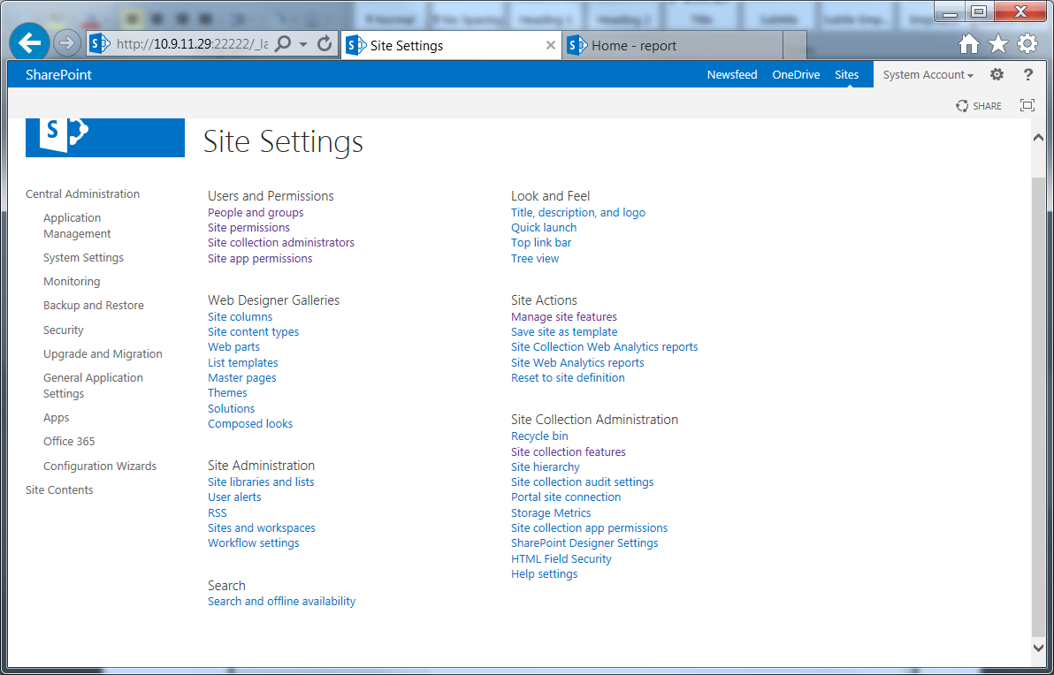

1. Locate **Report Server Integration Feature** and active it.

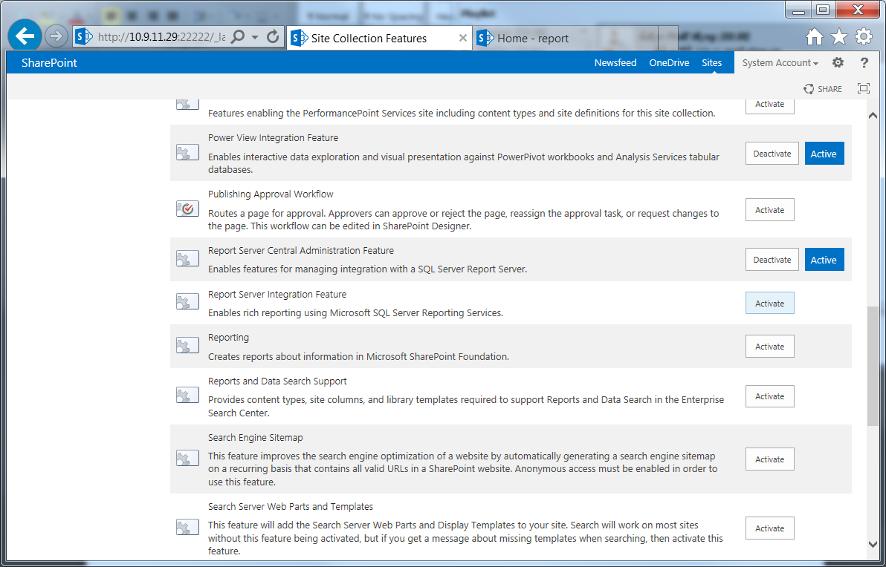

1. **Step 5: Create place holders for Reporting items**
2. Go to **Site Contents,** choose to **add an app,** then pick the **Document Library** and give it a name.

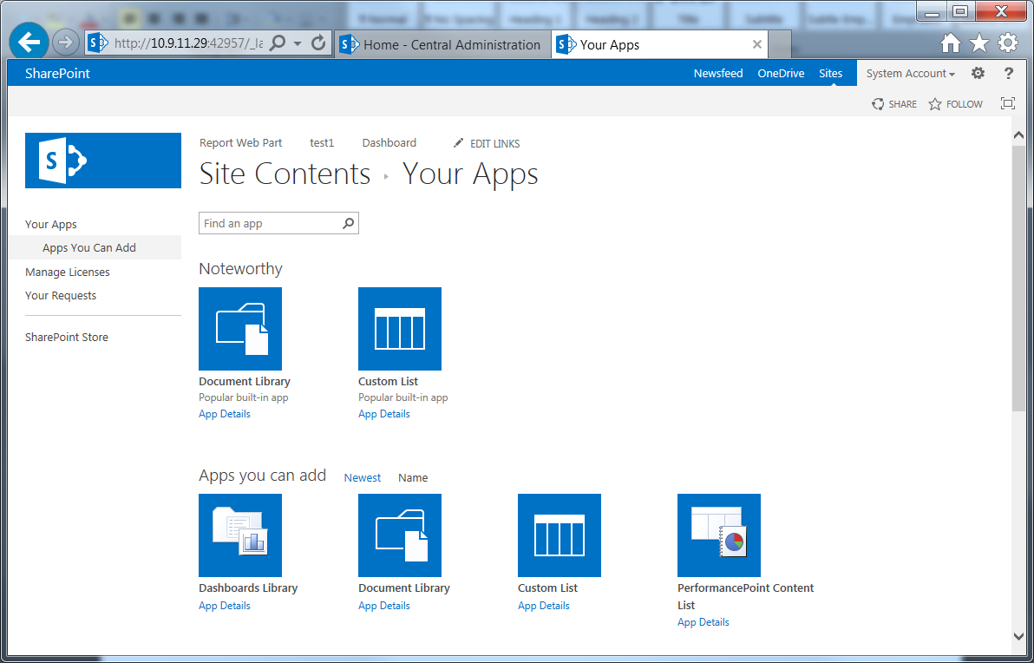

1. Go to the new Library’s **setting**, choose **advance setting**, and check the option **Allow management of content types**. Click **OK**

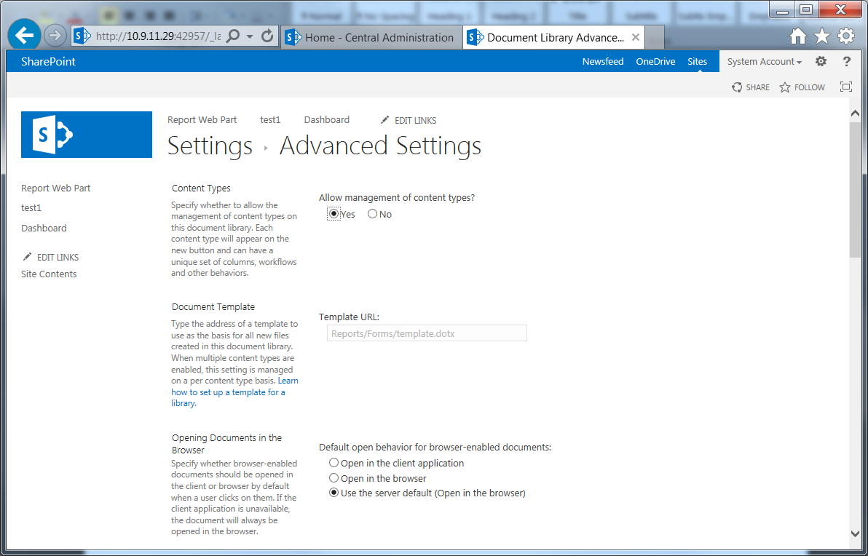

1. Click on option **Add from existing site content types**, and add **Report Builder Model, Report Builder Report, Report Data Source**

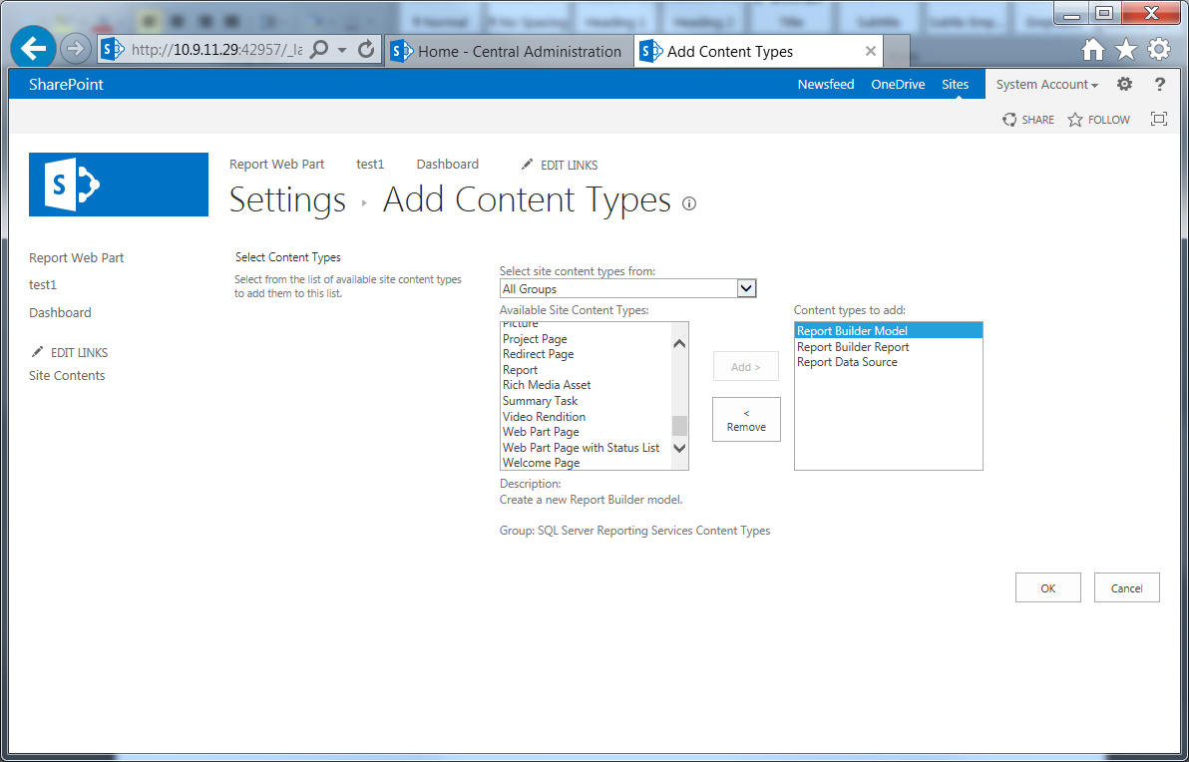

1. Back to the Site Content window, open the new created library, and create 3 folders acting as places where will be containing reports, data sets, and data sources.

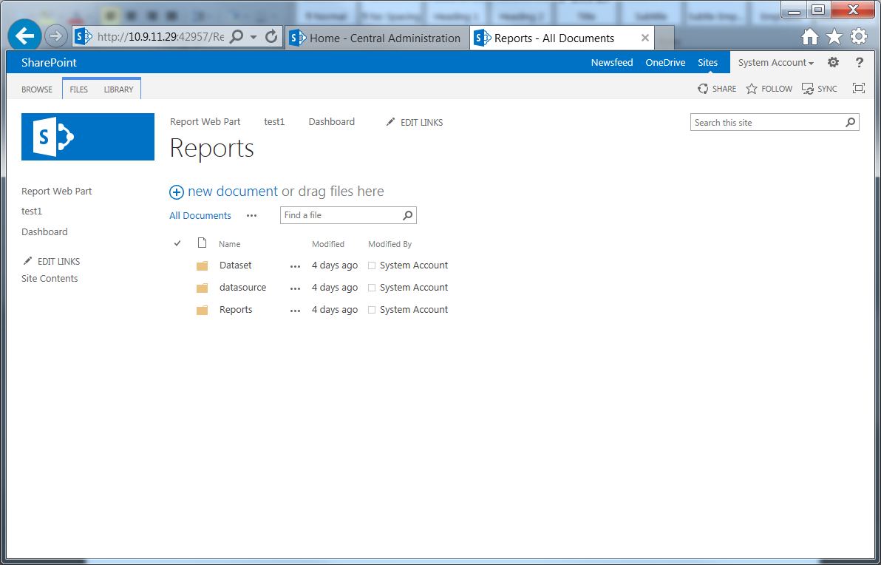

1. **Step 6: Deploy from SQL Server Data Tool**

In the project property, navigate the following information to the place holders created in the above step, and then deploy the whole project.

* TargetDatasetFolder
* TargetDataSourceFolder
* TargetReportFolder
* TargetServerURL
* TargetServerVersion
* OverwriteDatasets (optional)
* OverwriteDateSources (optional)

